# Friday, September 26, 2014 FHIM Meeting

Attendees:

* Steve Wagner
* Jay Lyle
* Kathleen Connor
* Robert Crawford
* Ioana Singureanu
* Susan Matney
* Don Lees
* Rob McClure
* David Bass

## Security and Privacy modeling

|  |
| --- |
| [FHIMS WG - Weekly IM Project Call](https://mail.google.com/mail/u/0/?#all/148acdd86cdc58f8) – note the new meeting information |
| 1. Revised GoToMeeting: [https://global.gotomeeting.com/join/947006365](https://www.google.com/url?q=https%3A%2F%2Fglobal.gotomeeting.com%2Fjoin%2F947006365&usd=2&usg=AFQjCNGkcenz4K5cBZK35u9RaZqPC_fOyg)  2. Use your microphone and speakers (VoIP) - a headset is recommended. Or, call in using your telephone. Dial +1 (646) 749-3131 Access Code: 947-006-365 Audio PIN: Shown after joining the meeting Meeting ID: 947-006-365 |  |

During today’s call we validated the modeling approach we will used to address the Security Label fields and identify the value set bindings we need to support in FHIM to constrain the model attributes.

* We will bind the abstract security field class to the code system and the concrete security field definitions to a value set
* Add an optional policy reference (URI) to all the classes? Domain specific implementations may constraint those out
* Individual classes with “code”, “uri”, [“reasonCode” – for Purpose of use]
* Add “reason for emergency” to Purpose of use = emergency then you need to use it.
  + ActReasonCode - ActInformationManagementReason - -> reasonCodes for PoU, consent overrides
    - ActConsentOverrideReason

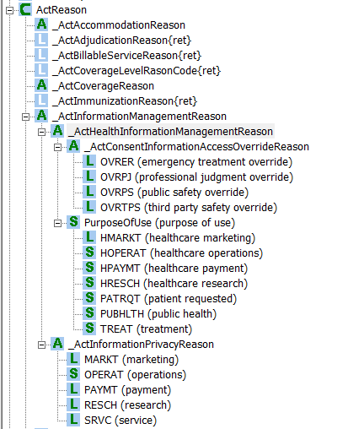

* + All the value sets for “classes” or “base classes” need to be added to FHIM terminology
* We should add the “Date Operations” value set (“ProvenanceEventCurrentState”) and will be bound for Permission class definition.
  + We may need to have a separate “Operation” class to allow it to be reused for Permission and Data Provenance and other instances when we need to specify an operation applied to an object.
* Confidentiality value sets may be bound to different attributes
* The attached spreadsheet summarizes the value set bindings required for Security and Privacy



* We discussed a May 2015 ballot of the logical representation of the Security and Privacy Domain in FHIM.

Action items:

* We will apply the changes discussed today to the FHIM
* Jay will email Kathleen the FHIM background documentation (e.g. charter, style guide, etc.)